NES PAPER PRESENTATION:

Paper structure:

1. Introduction

2. high level overview of IoT applications and devices

3. a brief presentation on hardware and software characteristics of IoT

4. electronic design automation (EDA) tools to support IoT

5. Wireless technologies and their challenges for connectivity of IoT devices

6. Conclusion

//

1 Introduction

2 Properties of Devices and Applications

2.1 Application Areas

2.2 Applications vs. Devices

3 Hardware & Software Architecture for IoT

3.1 Efﬁciency at Different Stages

3.2 Different Computing Layers

3.3 Approximate vs. Exact Computing

4 IoT Electronic Design Automation (EDA) Tools

5 Connectivity

5.1 Wireless Communication Technologies

5.2 Timing of Communication

5.3 Bandwidth & Data Rate of IoT Sensors

5.4 Analysis & Insight

6 Conclusions

//

Application areas/domain (but not limited to these categories)

- Healthcare

- Assisted Living

- Smart Building and Home

- Smart City

- Smart Industry

3 Hardware & Software Architecture for IoT:

3.1 General stages of IoT applications: They are designed at HW and SW levels.

{The First and last stages exist on every application, while the processing and storage may or may not exist in some applications}

1) data acquisition,

2) data processing,

3) data storage, and

4) data transmission.

3.2 Different computing layers :

1) device centric

2) gateway centric

3) fog centric

4) cloud centric

5) hybrid approach

3.3 Approximate vs Exact computing :

Data acquisition, Data processing, Data storage

4 IOT Electronic Design Automation (EDA):

IOT demands:

1) Design tools to support the growth of IOT devices

2) Design tools for IOT specific core

5. Connectivity

5.1 Wireless Communication Technologies

These technologies are used for

1. connecting the IoT device as local networks,and
2. connecting these local networks (or individual IoT devices) to the Internet

_ NFC

_ Bluetooth:

. Classic Bluetooth

. Bluetooth Low Energy (BLE)

. Bluetooth 5.0 (BT v5)

_ ZigBee:

_ WiFi:

. Conventional WiFi (IEEE 802.11 b/g/n)

. Low-power WiFi (802.11 ah) or HaLow

_ Cellular network:

_ Low Power Wide Area Network (LPWAN)

5.2 Timing of Communication:

The timing of data transmission schemes in IoT applications can be classied into three di_erent categories.

For designing an effcient IoT system, the timing of data transmission matters, especially for managing low power modes (deep sleep, standby, active).

_ Continuous: The IoT devices send or receive data

continuously

_ Sporadic: The IoT device collects and stores the

data and then transmits it whenever the connection

is available.

_ On-demand: 1. User driven = The IoT device can be requested by

the operator to send the collected data; 2. Event driven = The communication is done once a

speci_c event happens.

5.3 Bandwidth & Data Rate of IoT Sensors

Different IOT sensors:

Ambient/Object Temperature, Humidity,

Accelerometers and Gyroscopes,

Magnetometer,

Light,

Chemical Sensors,

Location-GPS,

Imaging,

Acoustic,

Ultra Violet (UV),

Ultrasonic,

RF radio modules,

Health Monitoring Sensors- Heart Rate, ECG, EMG, EEG, Blood Pressure, Respiration Rate, SpO2, Skin Conductivity.

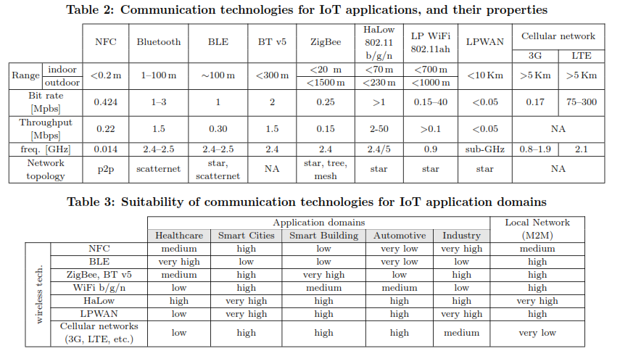

Data rates by different sensors & suitable technologies in particular application:

